Spiritual Parenting
Week 3 Humility is Required
Mike Colaw
Opening Illustration:
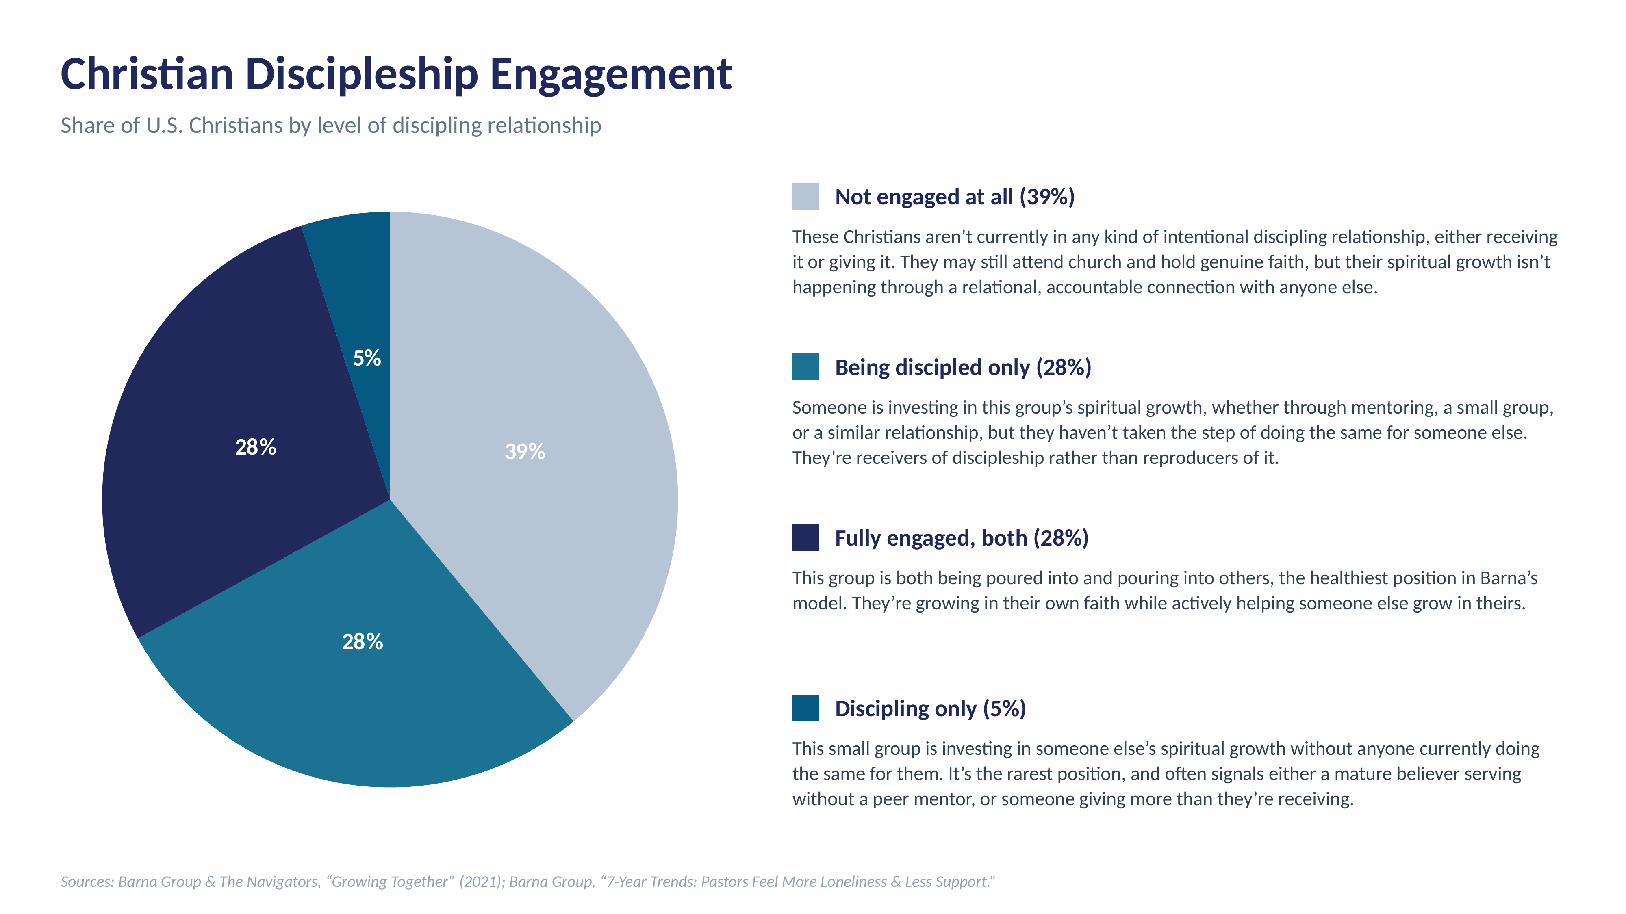
I want to offer you a discipleship chart.
A brief description of each area:
Not engaged at all (39%) – These Christians aren’t currently in any kind of intentional discipling relationship, either receiving it or giving it. They may still attend church and hold genuine faith, but their spiritual growth isn’t happening through a relational, accountable connection with anyone else.
Being discipled only (28%) – Someone is investing in this group’s spiritual growth, whether through mentoring, a small group, or a similar relationship, but they haven’t taken the step of doing the same for someone else. They’re receivers of discipleship rather than reproducers of it.
Fully engaged, both (28%) – This group is both being poured into and pouring into others, the healthiest position in Barna’s model. They’re growing in their own faith while actively helping someone else grow in theirs.
Discipling only (5%) – This small group is investing in someone else’s spiritual growth without anyone currently doing the same for them. It’s the rarest position, and often signals either a mature believer in between a peer mentor, or someone giving more than they’re receiving.
Guess which group is the most spiritually frustrated?
The most spiritually frustrated group of people are those who are the “disciplining someone only” group. That small 5% group of people who consistently invest in others’ spiritual growth without anyone doing the same for them are structurally positioned for the same one-directional, unsupported dynamic that Barna’s research links to burnout and loneliness among church leaders.
Why:
While the research doesn’t directly show cause some ideas can be constructed.
Why? Pressure to appear strong: If there is no one in the church you choose to submit to, it ironically positions you to have no place to deal with your own doubts or struggles.
Why? You are only as strong as your humility: Faking that you’re spiritually stronger and smarter than everyone else accidentally creates a spiritual “dark room” where your own doubts and struggles grow.
Why? Humility and a receptive heart posture feed the Fruit of the Spirit. Even if you are smarter than anyone else in the room, having no one you willingly submit to can harden your heart. It’s like a mighty oak trying to survive in an everlasting drought. Eventually you will stop producing fruit, the fruit of love, joy, peace, patience, kindness, goodness, faithfulness, gentleness and self control.
The problem with having a church in a highly educated and affluent area is simply that education and affluence without a humble heart becomes an engine for arrogance. And arrogance makes a heart unable to receive.

-----
Let’s go to the text:
2 Timothy 1:5; 2:1-2
I am reminded of your sincere faith, a faith that dwelt first in your grandmother Lois and your mother Eunice and now, I am sure, dwells in you as well. (2 Timothy 1:5, ESV)
You then, my child, be strengthened by the grace that is in Christ Jesus, and what you have heard from me in the presence of many witnesses entrust to faithful men, who will be able to teach others also. (2 Timothy 2:1–2 ESV)
-----
Notice the family language. There is no doubt that Timothy has a mentor in Paul and is the product of being mentored by his mother and grandmother.
From Christ on, faithful believers teach faithful believers who teach believers to be faithful. Maybe the most important thing you can ask a mentor, is who is mentoring them.
At a larger level, Timothy’s church has some strong voices in it. They came to the church not to grow together and learn, but to grasp at influence and push their theological bias (2 Tim. 4:3-4; 3:1-9). They are the undisciplined disciplers, the kind Paul confronts directly when he names Hymenaeus and Philetus, men who wandered from the truth through empty, quarrelsome arguments (2 Tim. 2:14-18). Paul tells Timothy to follow a different thread instead: the theological line of his mentor (2 Tim. 3:10-11) and his spiritually sound and humble mom and grandma (2 Tim. 1:5; 3:14-15).
Here is a clear way to say it.
Don’t become like the unteachable know it alls. Even if their debates and arguments are interesting, their hard heart will be their undoing.
-----
Final Thoughts:
My parents are amazing. Honestly, I hope I can grow up to be like them. When they walk into a church, they’re probably some of the smartest and most qualified people in the room to lead.
That said…
My dad is sharp. He really is. He was en route to becoming a lawyer when he felt called into ministry. By his own testimony, he really wrestled with God over it. He has an innate drive for success that’s impressive, up at 5 a.m. and doing whatever it takes until he crashed in the evening. When my brother and I were little boys, my dad popped into the house one evening, probably to grab a quick dinner before heading to another meeting, and my brother, about eight at the time, stood up to him. “Dad, how come you have time for everyone else, but not for us?” I remember thinking, Dang, he’s going to get in trouble.
After a few moments of processing the comment, my dad knelt down and said, “Boys, you’re right. I was wrong to be this absent.” He truly did change. I remember him taking us camping and hunting after that. One of the most powerful things my dad taught me wasn’t how to be the smartest or have the most authority, but how to be humble, how to say, “I was wrong,” and how to submit. He always talks about those he looks up and and submits to. His loving heart has said more to me than his brilliant mind.
Clear Statements:
Between you and the spiritual family your heart longs for will likely be a step of humility.
An unteachable heart will poison even the smartest of minds.
To the more Spiritually mature in the room. The heart posture you pass on matters more than you know.
To the younger believers in the room. It’s not only truth that you need, but a living truth that transforms you.
Next Steps Cards:
If you want to enter into a mentoring relationship would you be willing to acknowledge that on the next steps card?

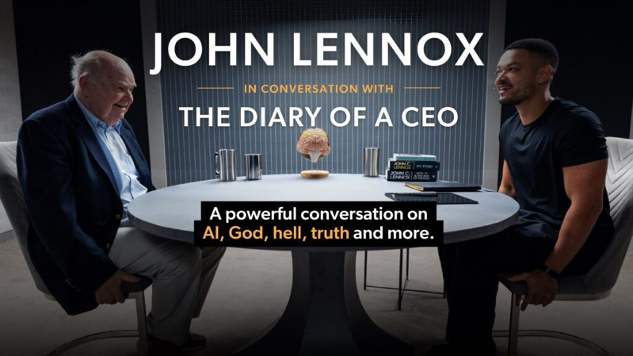
Closing Illustration 2 (Possible replacement)
Not long ago, someone shared with me an interview Steve Bartlett, host of the podcast Diary of a CEO, did with Dr. John Lennox.
In this interview, you can lean into all the apologetics and they matter. But you can also see something else happening, something beyond mere right answers.
Bartlett told Lennox that his witness was as convincing as the arguments he had made.
“You have a certain peace and contentment that I rarely see in people that I interview, but I almost always see in the Christians that I’ve interviewed. This is an interesting phenomenon for me.”

Bartlett referenced his interview with Canadian apologist Wesley Huff, whom he described as “happy, content, and rounded.”
“It seems to be a trend that a lot of the Christian apologists that I’ve interviewed have that anchoring that so many of us are looking for,” he added.
“There’s a real sense of that,” Lennox responded. “I sit in front of many people, and of course they often ask me questions I don’t even understand. But in life, that peace is very important to me.”
“When I look at you, I see someone who’s of infinite value, made in the image of God, and so what I say to you or think about you is hugely important to me. And I wish you well,” the apologist concluded.
Can you see what Dr. Lennox is reproducing? It isn’t merely his right ideas, it’s his right heart posture. He is an Oak Tree of solid Christian knowledge that still produces the fruit of the Spirit in such quantity that it “tastes good” to those around him. People experience love, joy, peace, patience, kindness, goodness, faithfulness, gentleness, and self-control, and that is wildly attractive. It’s the difference between a cadaver and a living body. The right material is there in both, but only one laughs, cries, cares, and leaves others wanting more.

Sources: Barna Group & The Navigators, “Growing Together” (2021); Barna Group, “7-Year Trends: Pastors Feel More Loneliness & Less Support.” Application to the “discipling only” segment is the author’s own, drawn by analogy between the two studies.

